ASSIGNMENT : 4

1.
Create a table comparing Amazon EBS and Amazon S3, listing at least 4 key differences (such as data type, access method, use case, and scalability) and give one real-world app example where each would be the better choice.
ANS :
Point | Amazon EBS | Amazon S3
1. Data type | Block storage — stores data in blocks, like a hard disk | Object storage — stores files/objects inside buckets
2. Access method | Attached to an EC2 instance and accessed like a local disk | Accessed through the S3 web interface, AWS CLI, SDKs, or APIs
3. Main use case | Operating systems, applications, databases, and files that need frequent read/write operations | Backup, images, videos, documents, static websites, and large amounts of files
4. Scalability | Storage capacity can be increased, but it is generally associated with an EC2 instance/volume | Highly scalable and designed to store virtually unlimited amounts of objects
5. Performance | Provides low-latency block-level storage for EC2 workloads | Optimized for durable object storage rather than acting like a local disk
6. Example | A MySQL database running on an EC2 server | A website storing user profile photos and videos
7. Storage structure | Volumes and blocks | Buckets and objects
8. Real-world application | Online banking application: EBS is suitable for the database disk because the application needs frequent read/write access

Easy way to remember
EBS = Hard Disk for EC2
S3 = Online Storage/Bucket for Files
For your assignment, you can write this conclusion:
Amazon EBS is better suited for applications that require block-level, low-latency storage, such as databases and operating systems running on EC2. Amazon S3 is better suited for storing and retrieving large amounts of files and objects, such as images, videos, backups, and documents.

2.
Launch a new EC2 instance in the AWS Free Tier and attach a new EBS volume of at least 2 GB to it using the AWS Management Console.<br><br><em><strong>Hint:</strong> After launching the instance, use the 'Volumes' section in EC2 to create and attach the volume.</em>
ANS :
Steps :
- Log in to the AWS Management Console and open the EC2 service.
- Click Launch Instance and enter a suitable name, such as EBS-Lab-Instance.
- Select a Free Tier eligible AMI such as Ubuntu or Amazon Linux.
- Select a Free Tier eligible instance type and choose or create a suitable key pair.
- Configure the required network settings and click Launch Instance.
- Wait for the EC2 instance to reach the Running state.
- In the EC2 dashboard, go to Elastic Block Store → Volumes.
- Click Create volume and select General Purpose SSD (gp3) as the volume type.
- Set the volume size to 2 GiB and select the same Availability Zone as the EC2 instance.
- Click Create volume to create the new EBS volume.
- Select the newly created 2 GiB volume and choose Actions → Attach volume.
- Select the EBS-Lab-Instance and click Attach volume.
- Verify that the EBS volume status changes to In-use and that it is attached to the EC2 instance.

Screenshot : EC2 instance successfully launched and running in AWS.
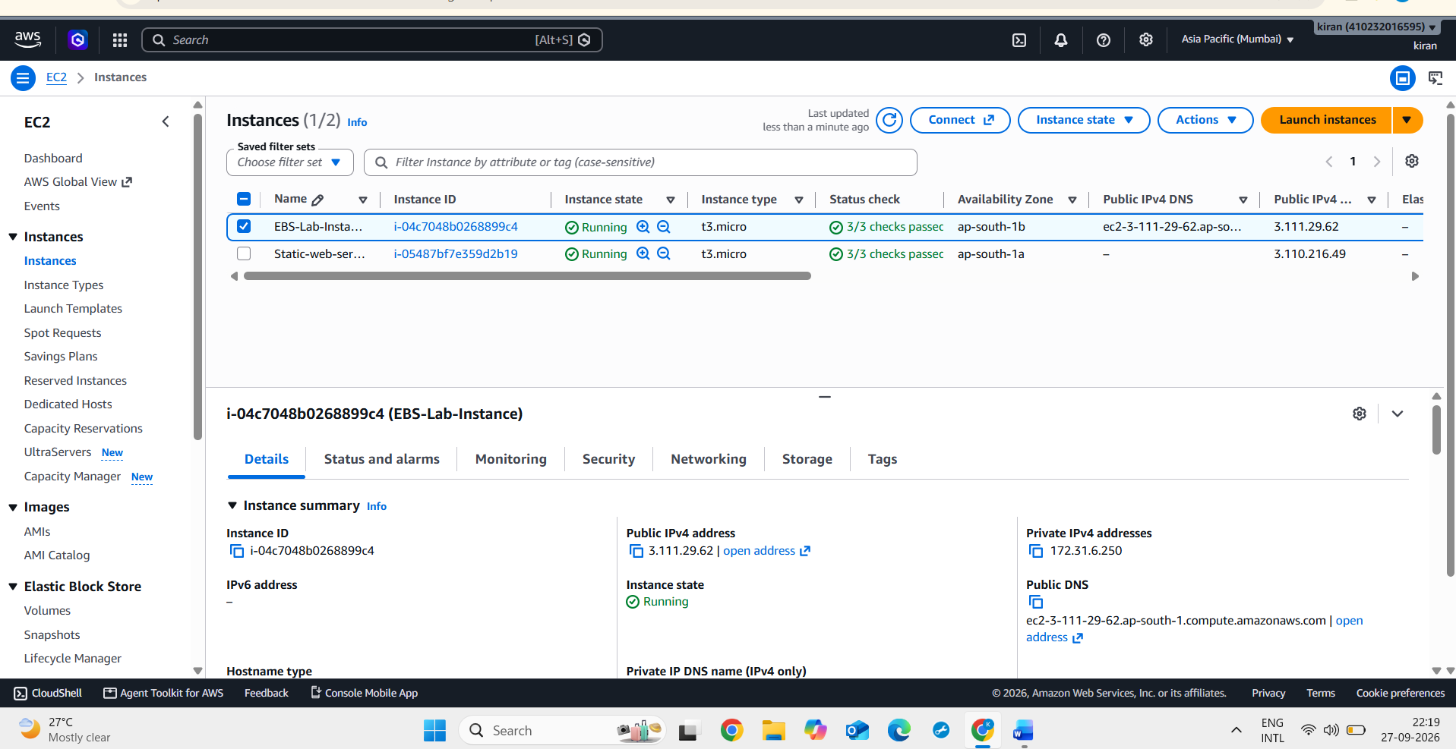
Screenshot : 2 GiB EBS volume successfully created and attached to the EC2 instance.
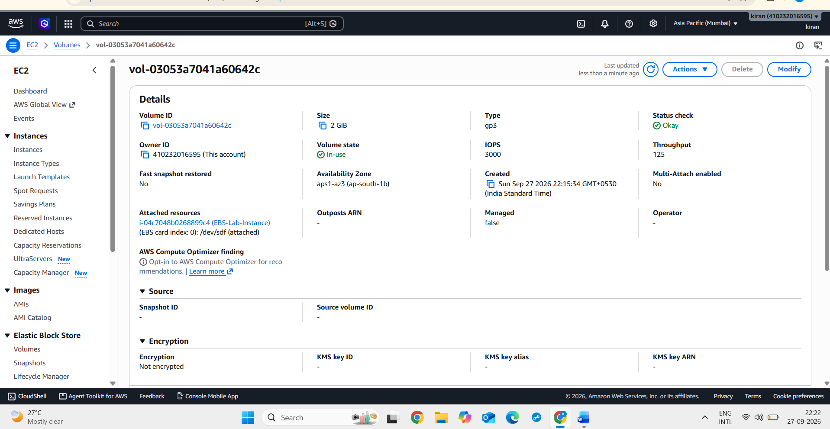
3.
Log in to your EC2 instance using SSH and format the attached EBS volume, then mount it to a new directory named /mnt/mydata.<br><br><em><strong>Hint:</strong> Use lsblk to find your volume, mkfs to format, and mount to attach it to the directory.</em>
ANS :
Steps :
- Connect to the EC2 instance:
The Ubuntu EC2 instance was accessed using SSH to perform storage management operations.
- Identify the attached EBS volume:
The lsblk command was used to list all available storage devices and identify the newly attached 2 GiB EBS volume.
- Format the EBS volume:
The identified EBS volume was formatted using the ext4 file system. Formatting prepares the volume so that the operating system can store and manage files on it.
- Create a mount directory:
A new directory named /mnt/mydata was created. This directory serves as the location where the EBS volume will be accessed.
- Mount the EBS volume:
The formatted EBS volume was mounted to /mnt/mydata, making its storage available through this directory.
- Verify the mounting:
The mounted volume was verified using storage-management commands. The output confirmed that the 2 GiB EBS volume was successfully associated with /mnt/mydata.
Screenshot : The 2 GiB EBS volume was identified, formatted, and successfully mounted on the /mnt/mydata directory.
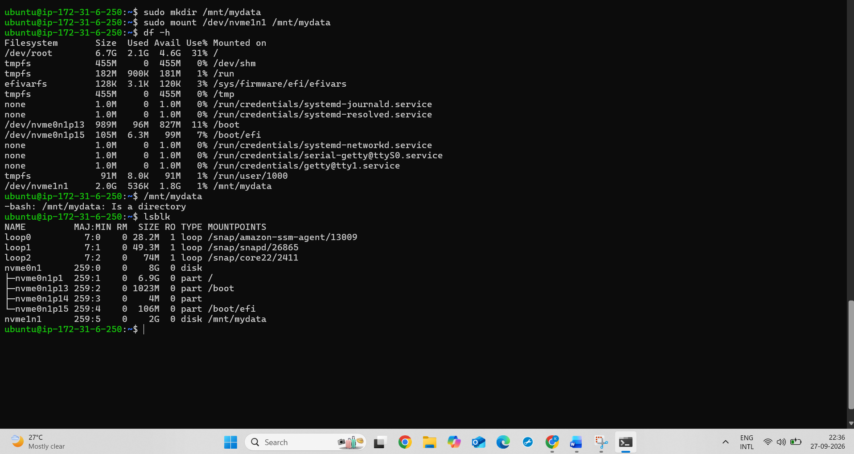

4.
Simulate a Zomato-style image upload: create a text file named zomato_menu.txt on your EC2 instance, copy it to your mounted EBS volume, and verify it is accessible from the new mount point.
ANS :
Steps :
- Connect to the EC2 instance:
Connected to the Ubuntu EC2 instance using SSH to perform the file storage operations.
- Create the menu file:
Created a text file named zomato_menu.txt on the EC2 instance to simulate a Zomato application file.
- Add menu data:
Added sample restaurant menu information to the zomato_menu.txt file.
- Copy the file to the EBS volume:
Copied the created file from the EC2 instance's home directory to the mounted EBS volume at /mnt/mydata.
- Verify the file:
Checked the /mnt/mydata directory to confirm that zomato_menu.txt was successfully copied to the EBS volume.
- Verify file accessibility:
Accessed the file from the /mnt/mydata mount point and displayed its contents to confirm that the file was readable.
Screenshot : The zomato_menu.txt file was successfully copied to the mounted EBS volume and verified from /mnt/mydata.
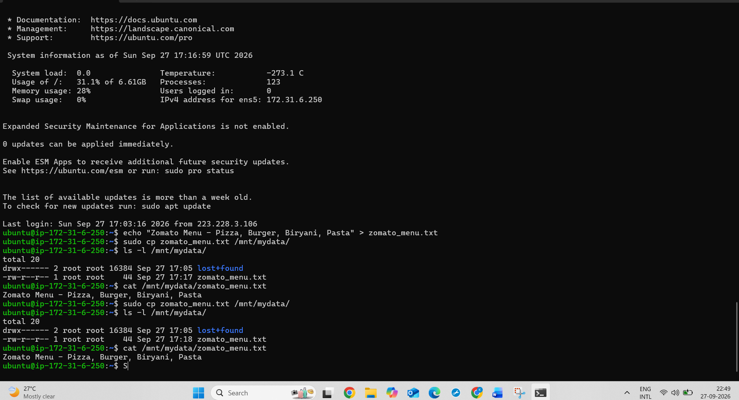
5.
Detach the EBS volume from your EC2 instance using the AWS Console, then reattach it to the same or a different instance. Describe what happens to the data you stored and why this behavior is useful for apps like Flipkart or Myntra order tracking.
ANS :
Steps :
- Open the AWS Management Console and go to EC2.
- In the EC2 dashboard, select Elastic Block Store → Volumes.
- Select the 2 GiB EBS volume attached to the EC2 instance.
- Choose Actions → Detach volume.
- Confirm the detachment and wait until the volume status changes to Available.
- Capture a screenshot showing the EBS volume in the Available state.
- Select the same EBS volume again and choose Actions → Attach volume.
- Select the same EC2 instance, EBS-Lab-Instance, and attach the volume.
- Connect to the EC2 instance using SSH.
- Run lsblk to identify the reattached 2 GiB EBS volume. The device name may be different after reattachment, such as /dev/nvme1n2.
- Mount the reattached volume to /mnt/mydata.
- Verify the stored files using:
ls -l /mnt/mydata
- Display the contents of the stored file using:
cat /mnt/mydata/zomato_menu.txt
- The previously stored Zomato menu data was displayed successfully, confirming that the data remained intact after detaching and reattaching the EBS volume.
Result
The EBS volume was successfully detached and reattached to the EC2 instance. The previously stored zomato_menu.txt file and its data were successfully recovered. This demonstrates that EBS provides persistent storage independent of the EC2 instance.
Screenshot : EBS volume detached
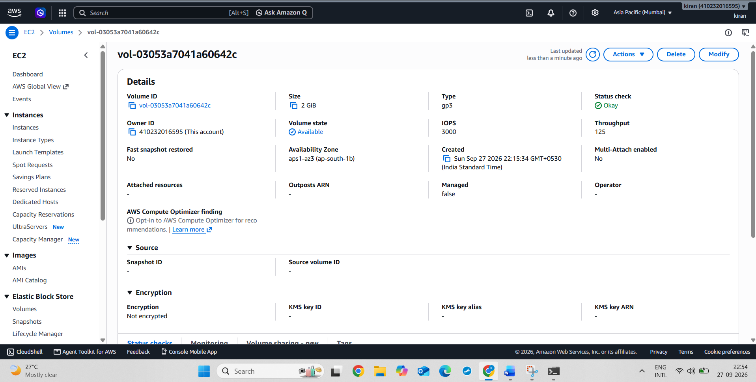
Screenshot : Data recovered after reattach
